Jira tool

1.JIRA was an open source tool available for anyone to download.

2.  Jira is used for issue tracking and project management.

3. **Jira Software** includes the base software, including agile project management features

jira terminology

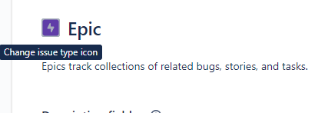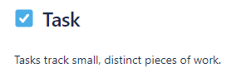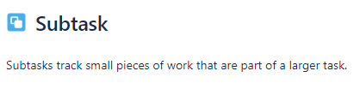

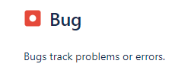

Login to jira



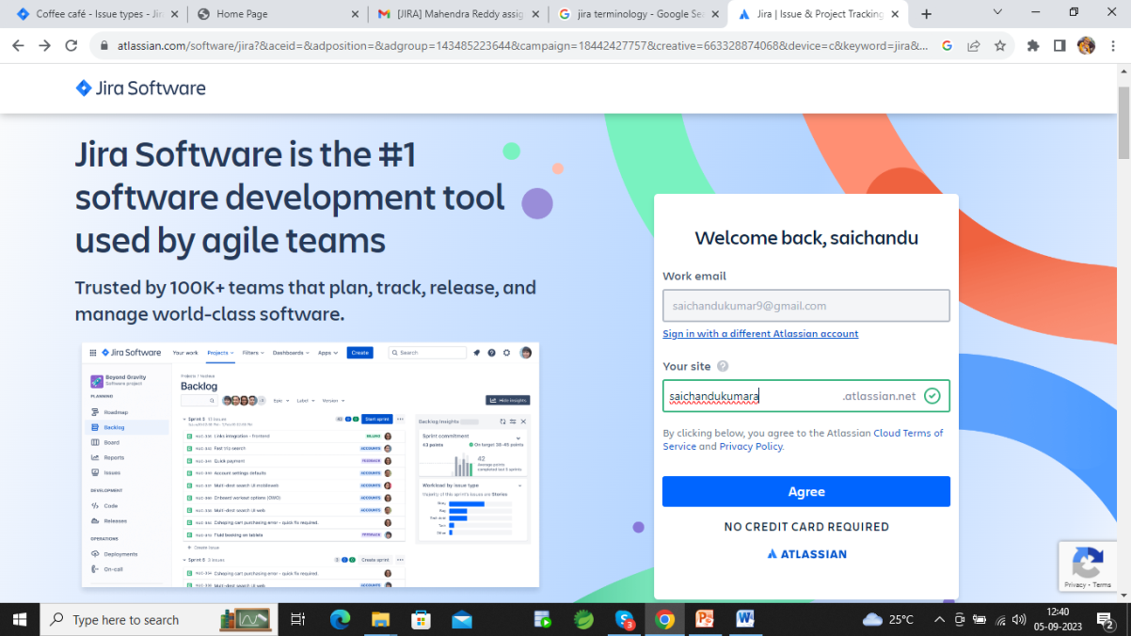

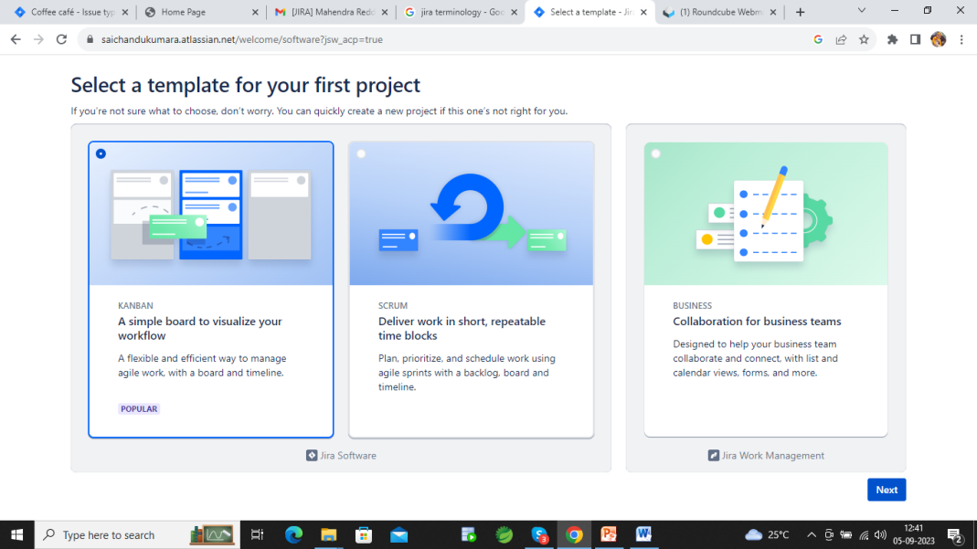

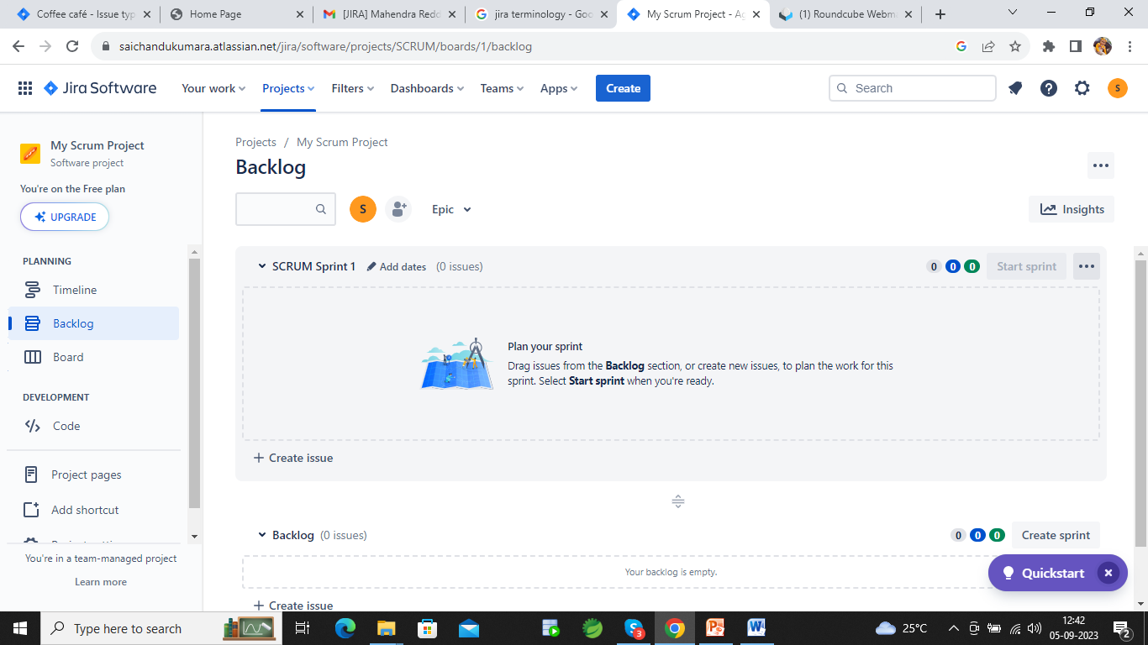

Project creation



Click on Project in jira dashboard select create project option

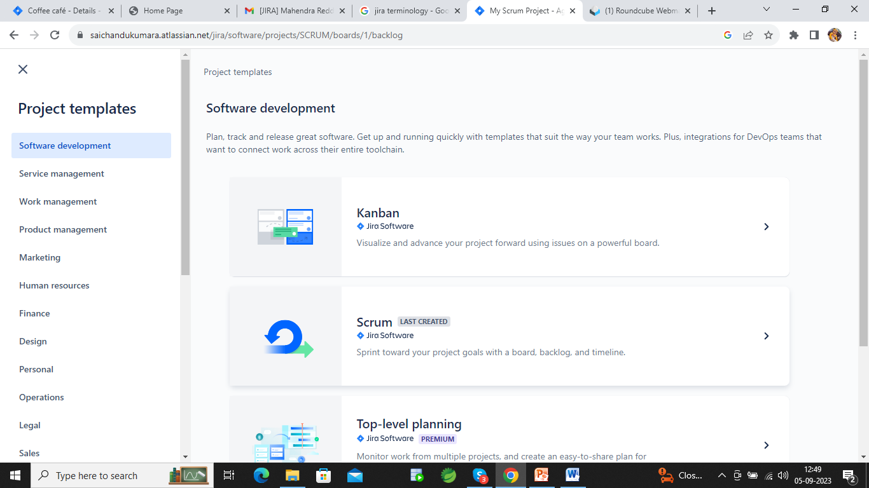

Select Scrum template

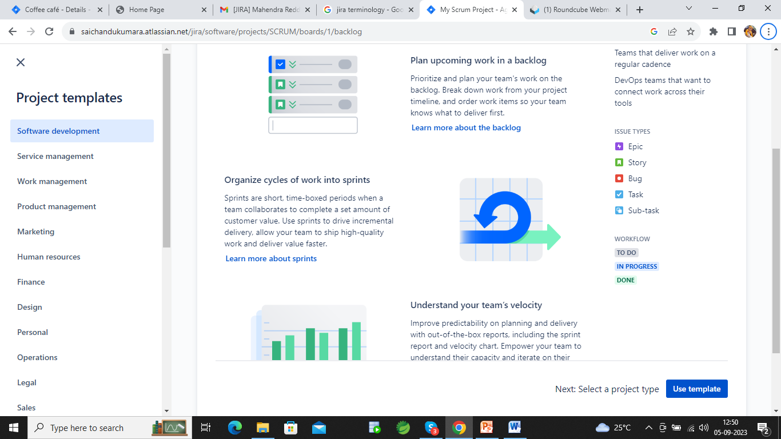

Click on use template

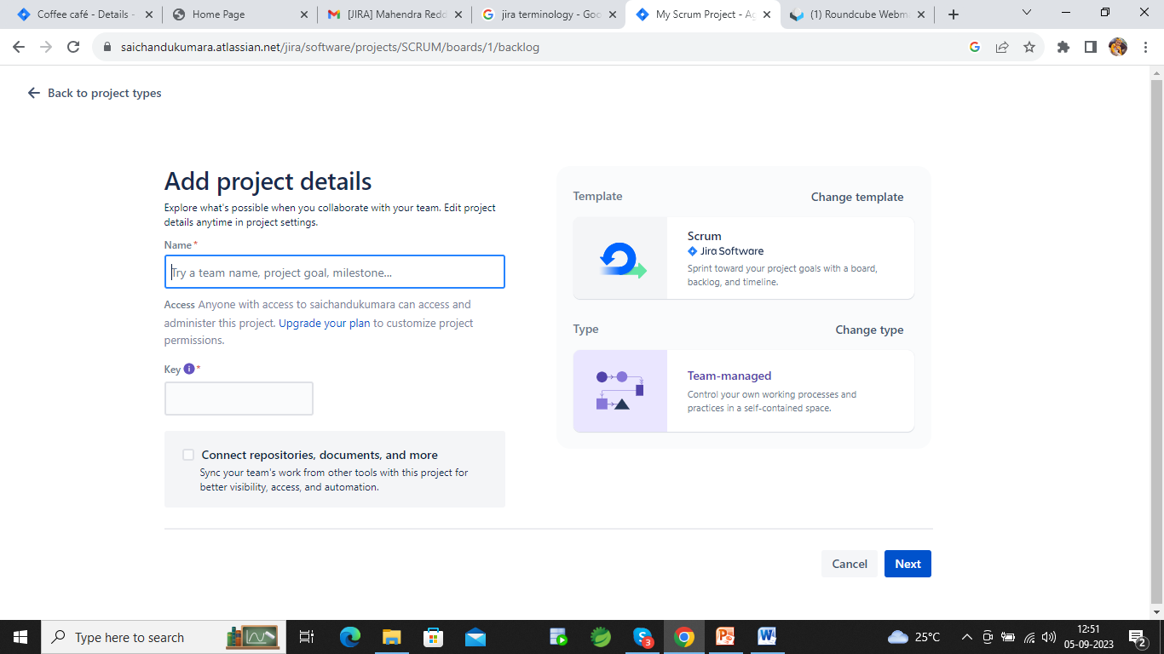

Give project name click on next

**Creation of backlogs**

Backlogs means total project requirements

In Backlogs there is Epics and stories

Creation of Epics



click on create button

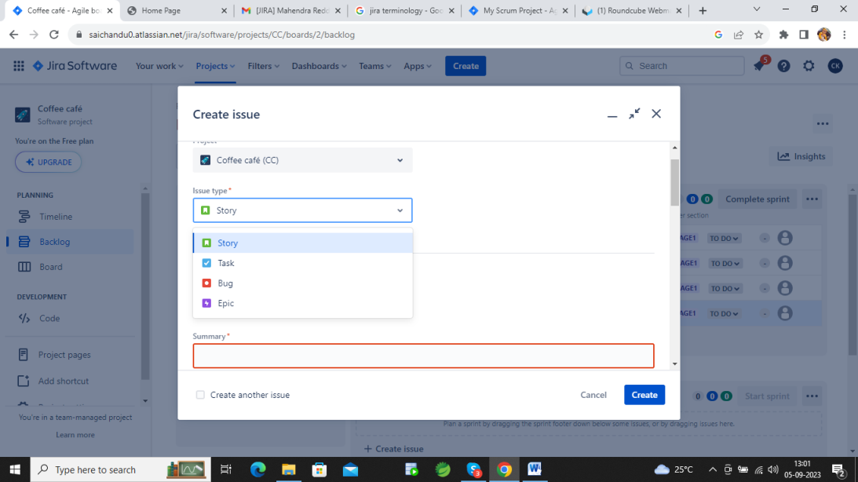

Select Epic issue type

Write required fields

Click on create then epics will create

Story

Same has Epic creation but we have to select issue type has a story.

Backlog

This Epic and stories we can see in backlog page

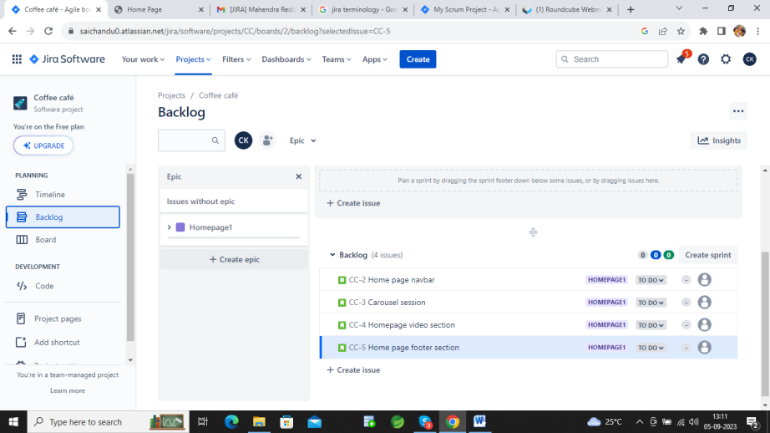

Sprint planning

Drag and drop that backlogs in above create sprint block which we have to implement in first sprint

Then click on Create sprint and write all required fields

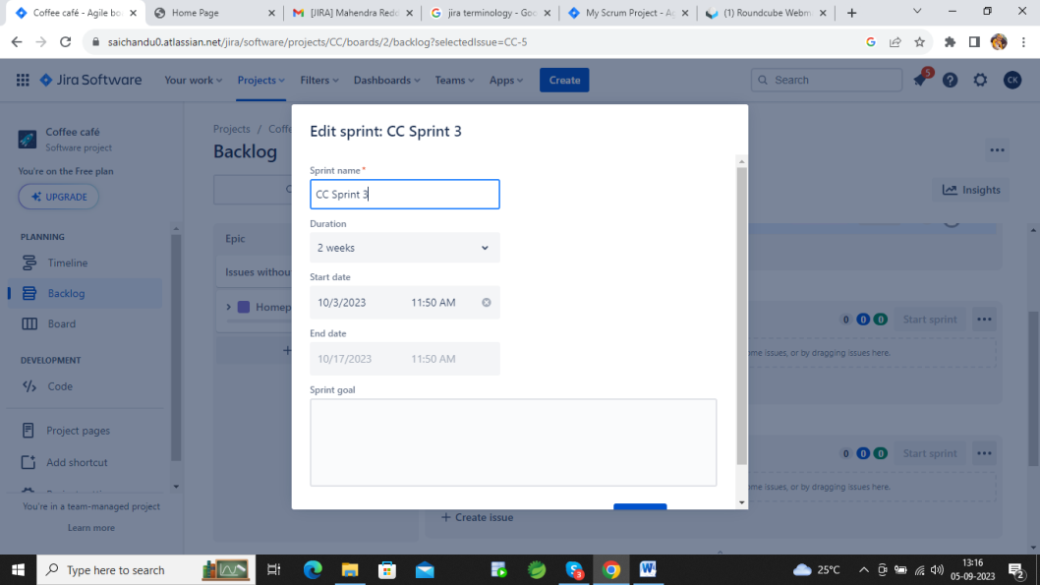

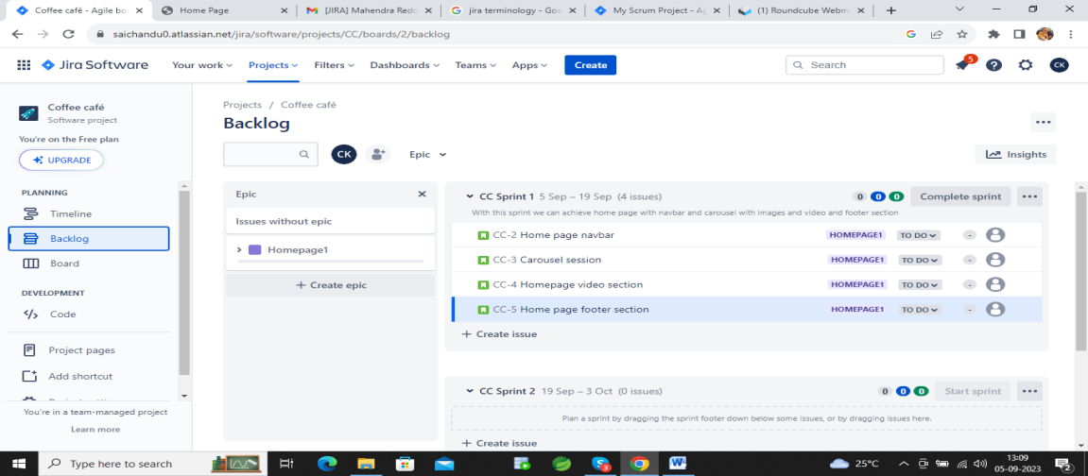

When we start the sprint the epic and Stories will move to board

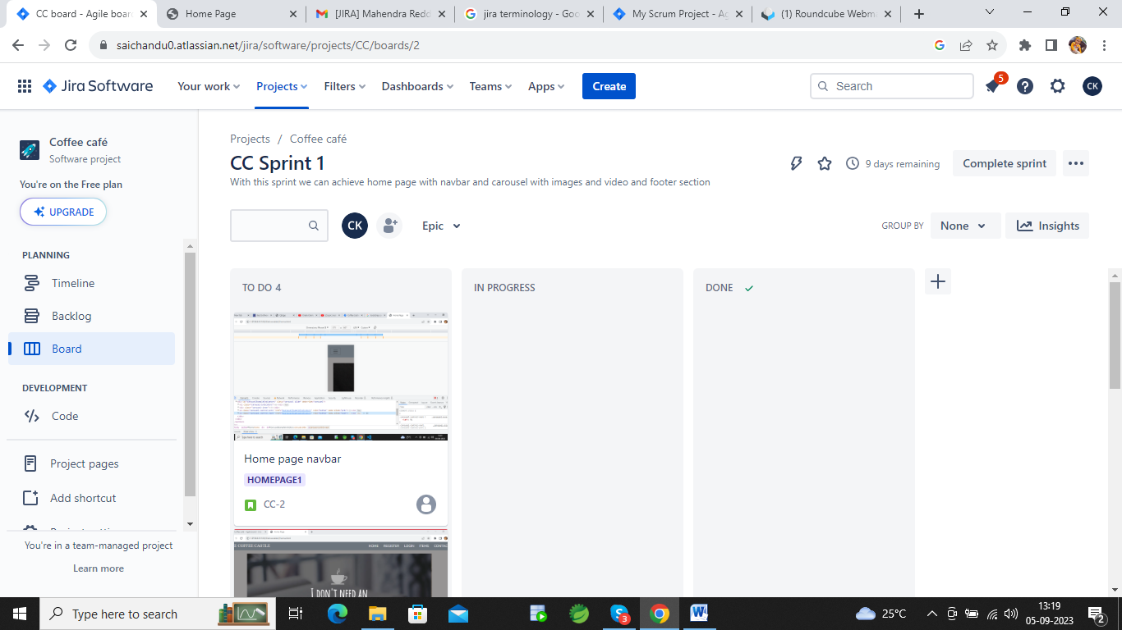

Issue adding

Click on + on board then write which board we want

Editing work flow

Click on click on Configure workflow

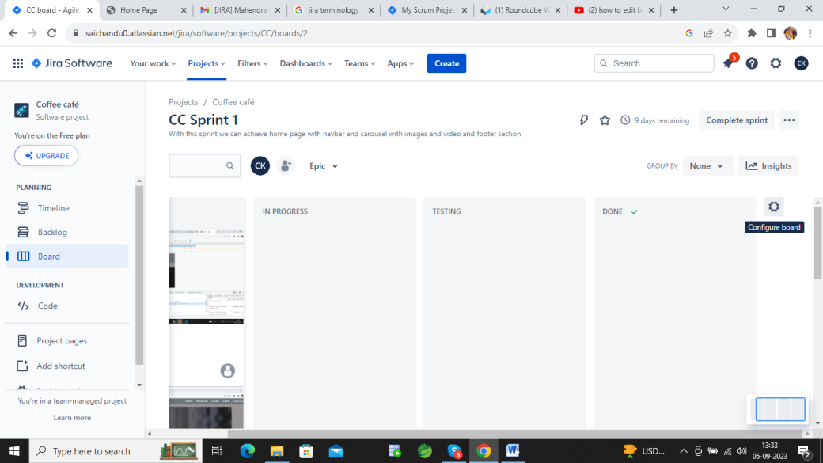

Drag and drop the flow of tasks

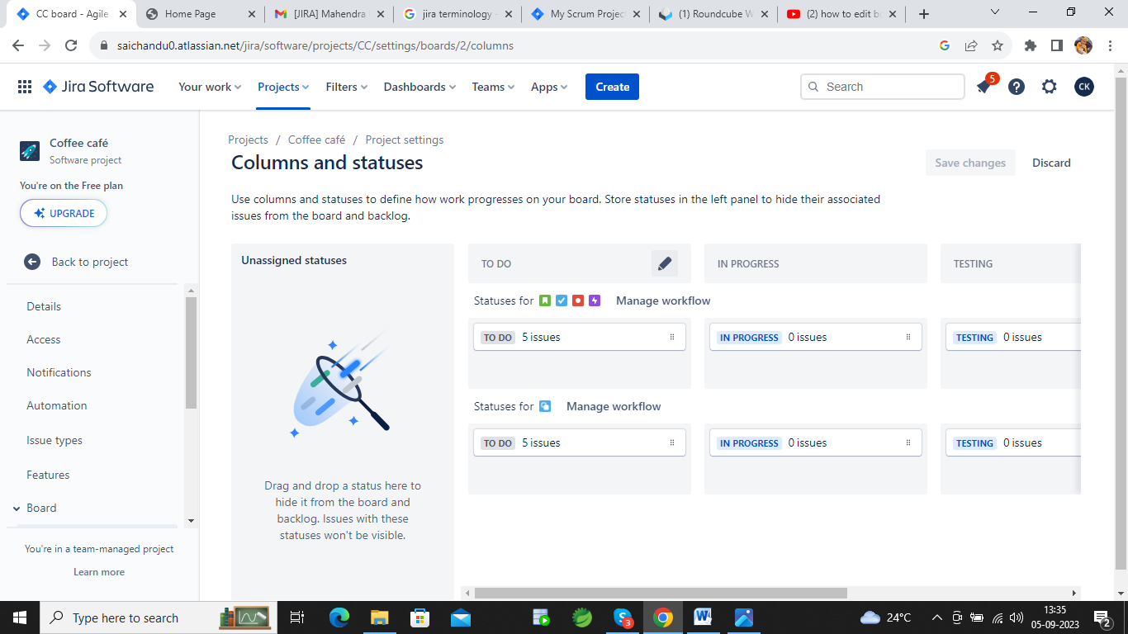

Adding team

Click on logo of user add people

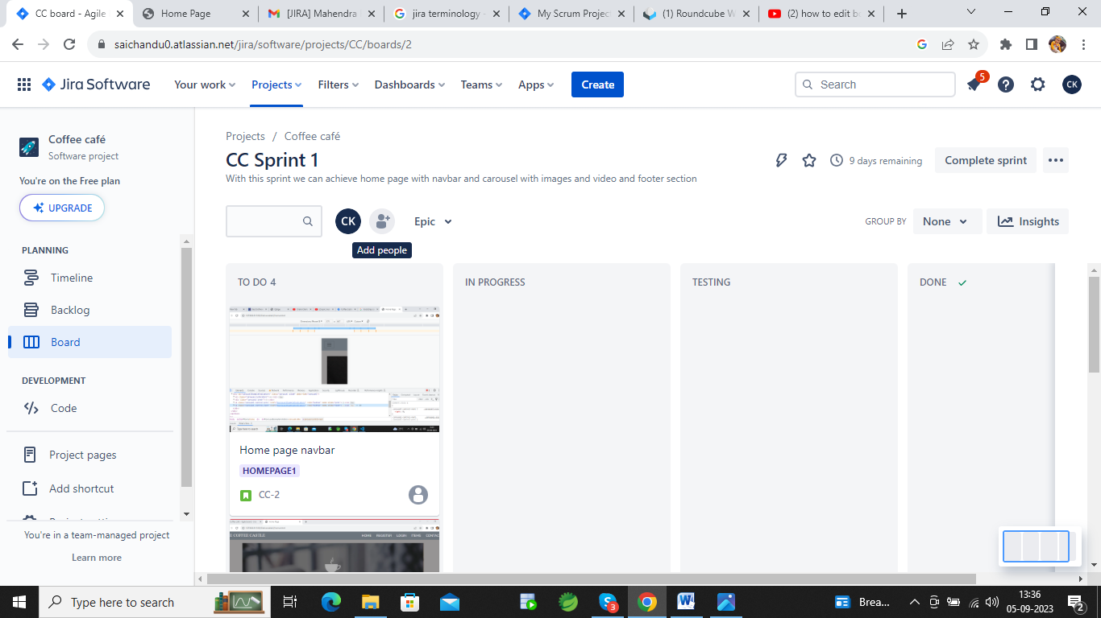

Add team member’s mail address

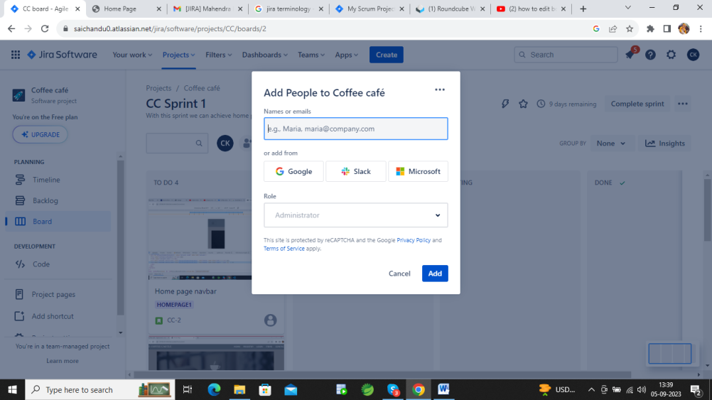

Click on adds People should accept the request then in board level the work will displayed.

Assigning work in jira

For that first we need to add the people

Then go to backlog page.in sprint level there is icon as assignee. Click on that and select mail for who wants to assignee.so that the work will display there bord.

